1. **Setup jenkins CICD pipeline using freestyle job using Docker containers using below code.** [**https://github.com/betawins/hiring-app.git**](https://github.com/betawins/hiring-app.git)

**Stages: 1) Git Clone**

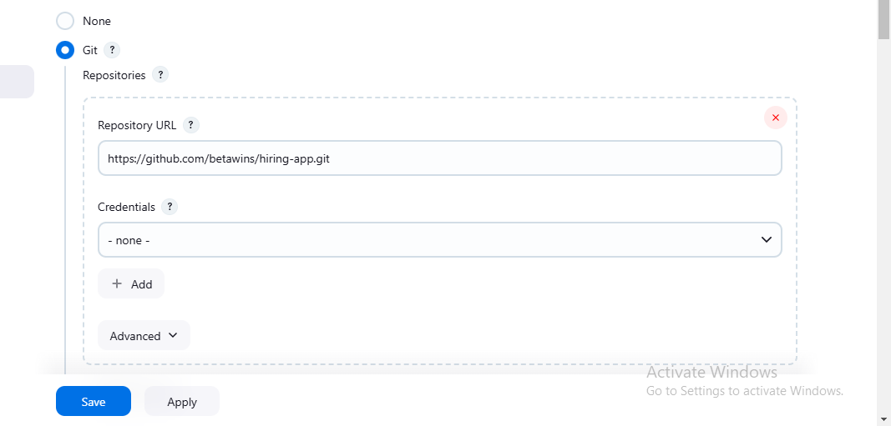

1. **Sonarqube Integration**

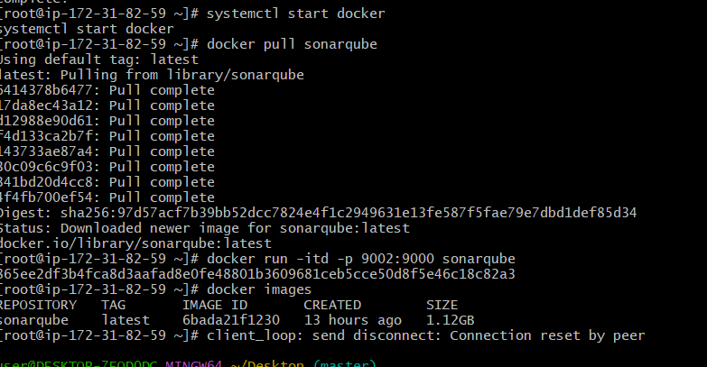

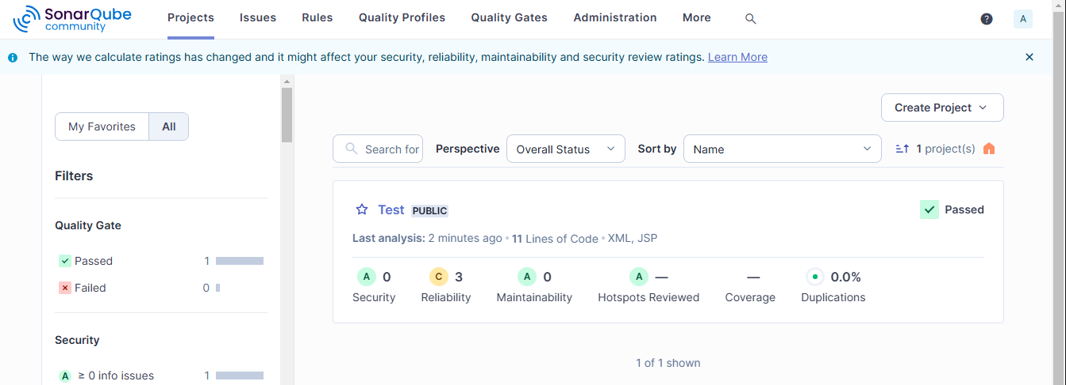

1. **Maven Compilation**

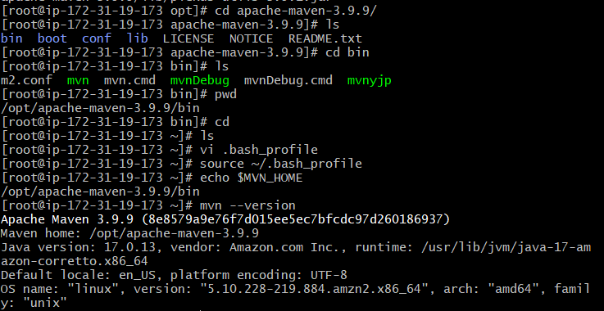

**4) Nexus Artifactory**

**5) Slack Notification**

**6) Deploy On tomcat**

**2) Setup a jenkins CICD pipeline using Declarative pipeline using feature-1.1 branch.** [**https://github.com/betawins/sabear_simplecutomerapp/tree/feature-1.1**](https://github.com/betawins/sabear_simplecutomerapp/tree/feature-1.1) **stages: 1) Git Clone 2) Sonarqube Integration 3) Maven Compilation 4) Nexus Artifactory 5) Slack Notification 6) Deploy On tomcat 3) Setup a jenkins CICD pipeline using Scripted pipeline using feature-1.1 branch.** [**https://github.com/betawins/sabear_simplecutomerapp/tree/feature-1.1**](https://github.com/betawins/sabear_simplecutomerapp/tree/feature-1.1) **stages: 1) Git Clone 2) Sonarqube Integration 3) Maven Compilation 4) Nexus Artifactory 5) Slack Notification 6) Deploy On tomcat 4) Write sample skeleton of pipelines. 5) Create a parametirized job in jenkins.** [**https://github.com/betawins/spring3-mvc-maven-xml-hello-world-1.git**](https://github.com/betawins/spring3-mvc-maven-xml-hello-world-1.git) **6) Setup one slave machine for jenkins.**